The Pomodoro Plan

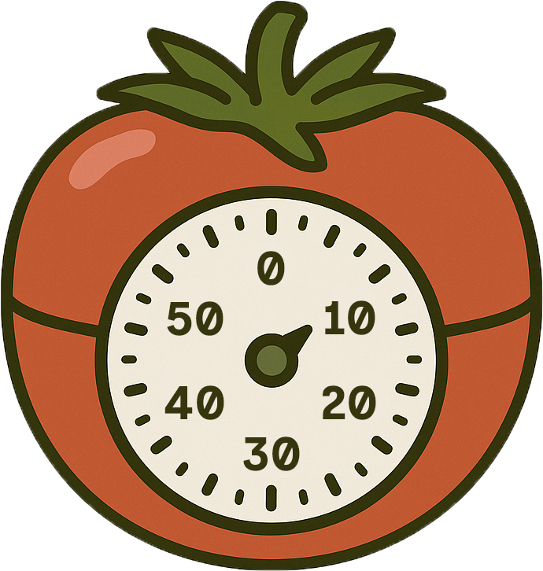

Take what you have learned from the course and add your tasks below into segments that you think are achieveable.

Sprint 1 (25 mins)
Task 1:
5 minute break

Sprint 2 (25 mins)
Task 2:
5 minute break

Sprint 3 (25 mins)
Task 3:
30 minute break

Sprint 4 (25 mins)
Task 4:
5 minute break

Sprint 5 (25 mins)
Task 5:
5 minute break

Sprint 6 (25 mins)
Task 6:

